**­­­­Cellular System Infrastructure**

Early wireless systems had a high-power transmitter, covering the entire service area. This required a very huge amount of power and was not suitable for many practical reasons.

The cellular system replaced a large zone with a number of smaller hexagonal cells with a single BS (base station) covering a fraction of the area. Evolution of such a cellular system is shown in the given figures, with all wireless receivers located in a cell being served by a BS.

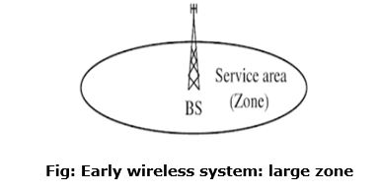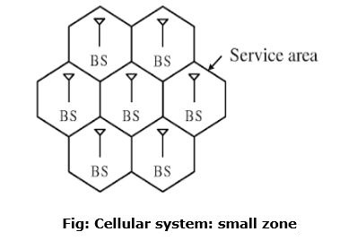

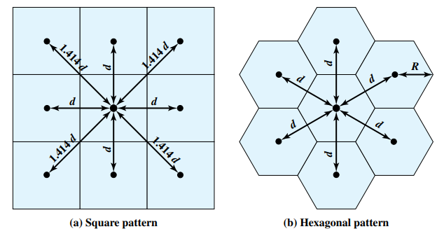

The first design decision to make is the shape of cells to cover an area. A matrix of square cells would be the simplest layout to define however, this geometry is not ideal. If the width of a square cell is *d*, then a cell has four neighbors at a distance *d* and four neighbors at a distance √2d.

**Frequency Reuse:** In a cellular system, each cell has a base transceiver. The objective is to use the same frequency in other nearby cells. This allowing the frequency to be used for multiple simultaneous conversations. Generally, 10 to 50 frequencies are assigned to each cell, depending on the traffic expected.

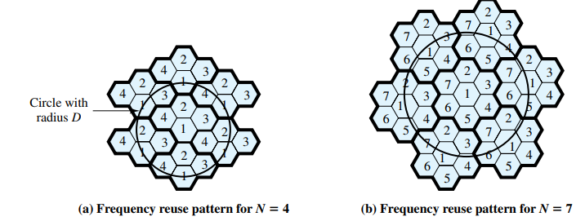

In a cellular structure, a MS (mobile station) needs to communicate with the BS of the cell where the MS is currently located and the BS acts as a gateway to the rest of the world. Therefore, to provide a link, the MS needs to be in the area of one of the cells (and hence a BS) so that mobility of the MS can be supported. Several base stations are connected through hard-wires and are controlled by a BS controller (BSC), which in turn is connected to a mobile switching center (MSC).

Several mobile switching centers are interconnected to a PSTN (public switched telephone network). To provide a better perspective of wireless communication technology, simplified system infrastructure for cellular system is shown in the figure:

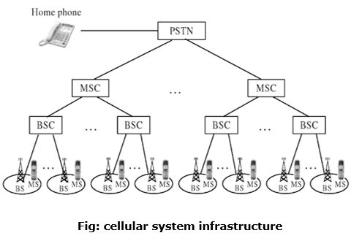

A cellular system requires a fairly complex infrastructure. A generic block diagram in shown in the figure:

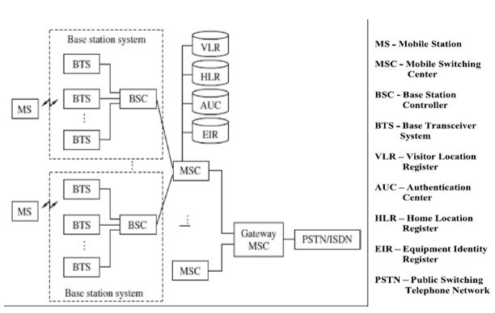

A BS consists of a base transceiver system (BTS) and a BSC. Both tower and antenna are a part of the BTS, while all associated electronics are contained in the BSC.

The HLR (home location register) and VLR (visitor location register) are two sets of pointers that support mobility and enable the use of the same telephone numbers worldwide.

The AUC (authentication center) unit provides authentication and encryption parameters that verify the user's identity and ensure the confidentiality of each cell.

The EIR (equipment identity register) is a database that information about identity of mobile equipment. Both AUC and EIR can be implemented as individual stand-alone units or as a combined AUC/EIR unit.

**Principle of Cellular System/Mobile Cellular Call:**

**• Mobile unit initialization:** When the mobile unit is turned on, it scans and selects the strongest setup channel and monitors that channel.

**• Mobile-originated call:** A mobile unit originates a call by sending the number of the called unit on the preselected setup channel. The receiver at the mobile unit first checks that the setup channel is idle by examining information in the forward (from the BS) channel.

**Paging:** Paging is the one-to-one communication between the **mobile** and the base station. **Paging** is a procedure the network uses to find out a subscriber's location before actual call establishment.

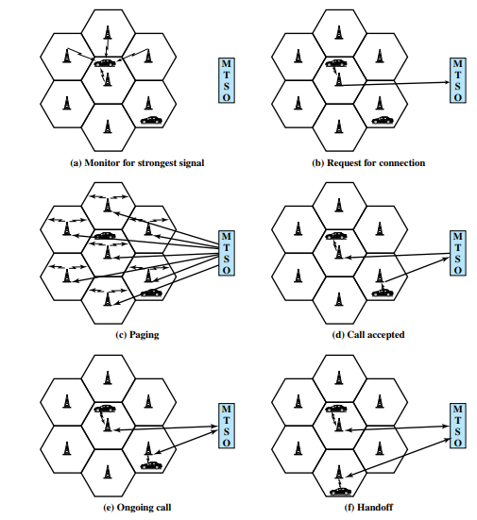

• Call accepted: The called mobile unit recognizes its number on the setup channel being monitored and responds to that BS, which sends the response to the MTSO. The MTSO sets up a circuit between the calling and called BSs.

• Ongoing call: While the connection is maintained, the two mobile units exchange voice or data signals, going through their respective BSs and the MTSO.

• Handoff: If a mobile unit moves out of range of one cell and into the range of another during a connection, the traffic channel has to change to one assigned to the BS in the new cell.

• Call termination: When one of the two users hangs up, the MTSO is informed and the traffic channels at the two BSs are released.

• Call drop: During a connection, because of interference or weak signal spots in certain areas, if the BS cannot maintain the minimum required signal strength for a certain period of time, the traffic channel to the user is dropped and the MTSO is informed.